INTERNSHIP TECHNICAL REPORT
Week 3 Extension: Infrastructure as Code, CI/CD & Containerization
Prepared by: Dilip Kumar
Cloud & DevOps Internship Program
Date: July 01, 2026
AWS | Terraform | Docker | GitHub Actions | CloudWatch

Learning Objectives
This report documents the practical implementation of Infrastructure as Code, containerization, continuous integration and deployment, and cloud monitoring during Week 3 of the internship program. The primary objectives achieved are summarized below.
- Provision AWS infrastructure using Terraform.
- Understand Infrastructure as Code (IaC) best practices.
- Build CI/CD pipelines using GitHub Actions.
- Containerize applications using Docker.
- Deploy applications to AWS automatically.
- Implement infrastructure versioning and state management.

Day 1 – Terraform Fundamentals

Topics Covered
- Infrastructure as Code (IaC)
- Terraform Architecture
- Providers
- Resources
- Variables
- Outputs
- Terraform State

Implementation
Terraform was installed and configured with the AWS provider to provision infrastructure declaratively. Variables were used instead of hardcoded values to make the configuration reusable and environment-independent.
- Installed Terraform and configured the AWS provider.
- Created an S3 bucket using Terraform.
- Created an EC2 instance using Terraform.
- Used variables instead of hardcoded values.
- Output the EC2 Public IP.
- Destroyed all resources using Terraform to validate teardown.
The terraform.tfvars file below defines the region, credentials reference, bucket name, AMI ID, and instance type used across the configuration, and confirms successful initialization of the Terraform working directory.
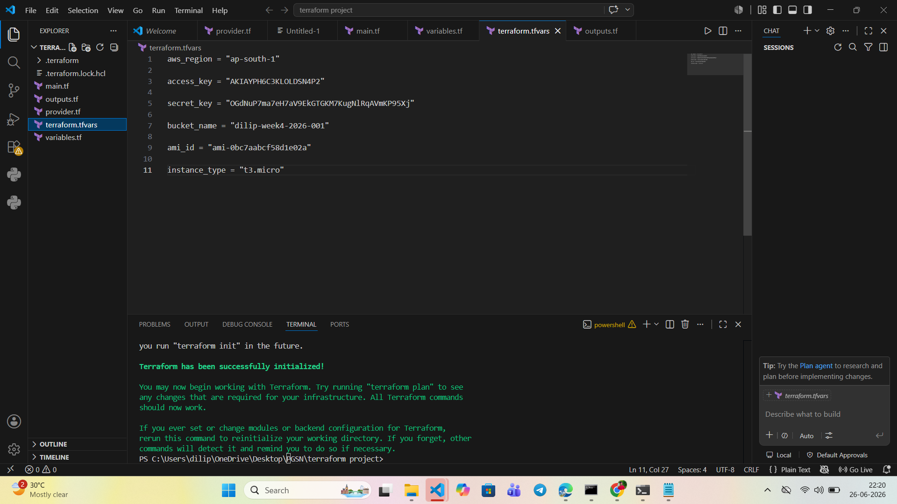
Figure 1: Terraform variables configuration and successful ‘terraform init’ execution in Visual Studio Code.
Once applied, the defined Security Group, S3 bucket, and EC2 instance were provisioned successfully in the AWS Management Console, confirming that the Terraform configuration was syntactically correct and that the AWS provider was authenticated properly.
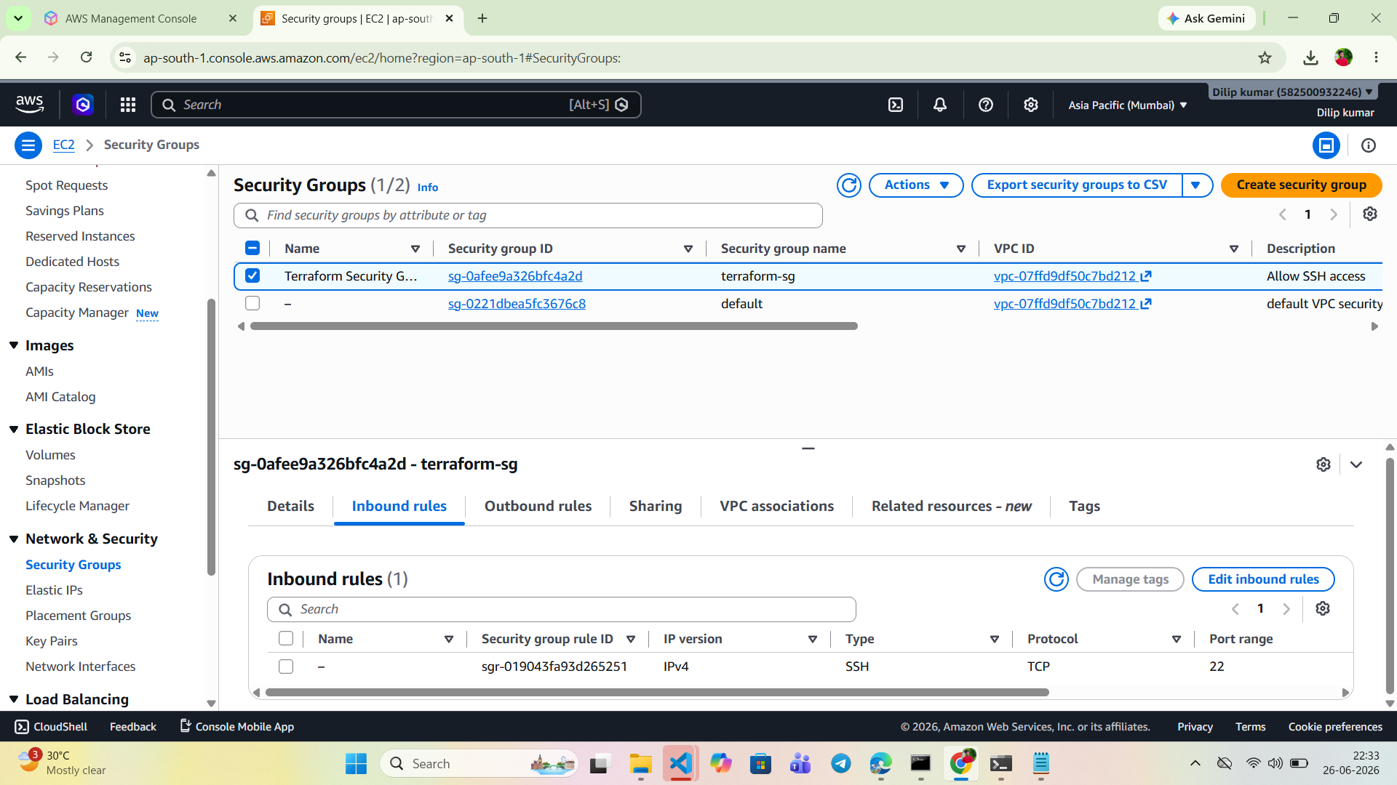
Figure 2: AWS Security Group (terraform-sg) created via Terraform, showing an inbound SSH rule on port 22.
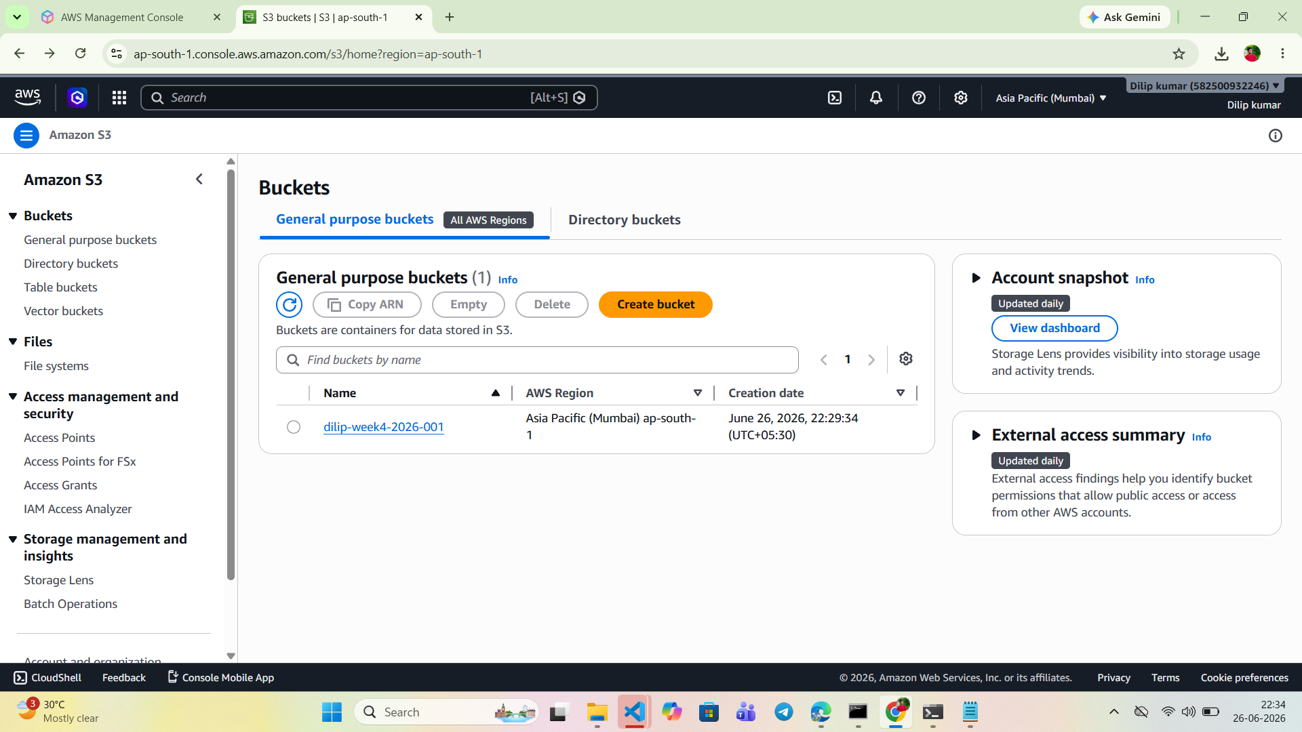
Figure 3: Amazon S3 bucket (dilip-week4-2026-001) provisioned in the Asia Pacific (Mumbai) region using Terraform.
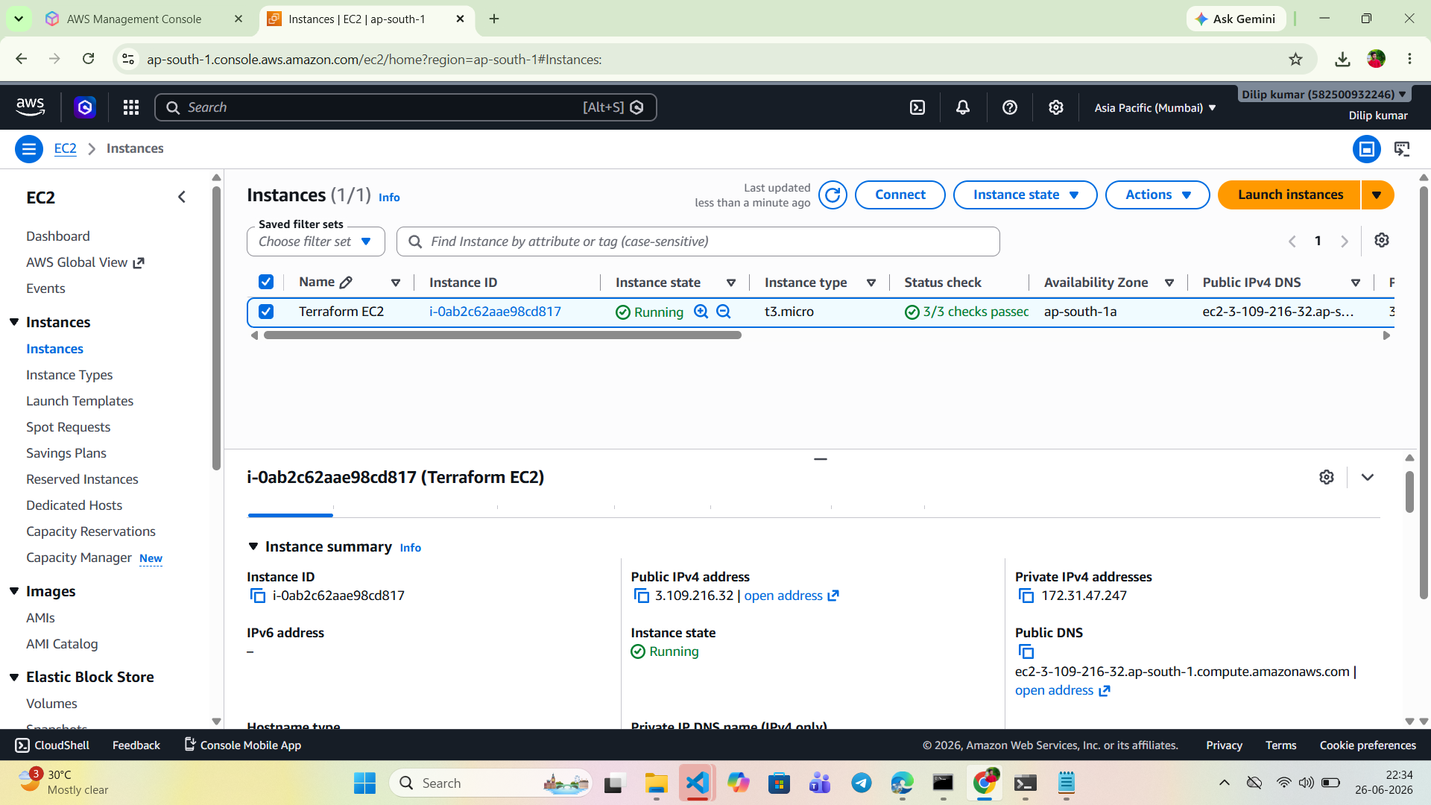
Figure 4: EC2 instance (Terraform EC2) launched via Terraform, shown in the ‘Running’ state with a t3.micro instance type.

Day 2 – Modular Infrastructure

Topics Covered
- Terraform Modules
- Remote State
- Backend Configuration
- Terraform Workspaces

Implementation
Building on Day 1, the Terraform configuration was refactored into reusable modules to improve maintainability and support multi-environment deployments.
- Created a reusable VPC Module.
- Created an EC2 Module.
- Created a Security Group Module.
- Stored Terraform state in an S3 backend for centralized state management.
- Created separate Dev and Prod workspaces.
- Deployed infrastructure using the newly created modules.
The VPC module’s variables.tf file defines reusable inputs (VPC CIDR, VPC name, public subnet CIDR, and availability zone), and the terminal confirms the available Terraform workspaces (default, dev, prod) with the dev workspace selected for this deployment.
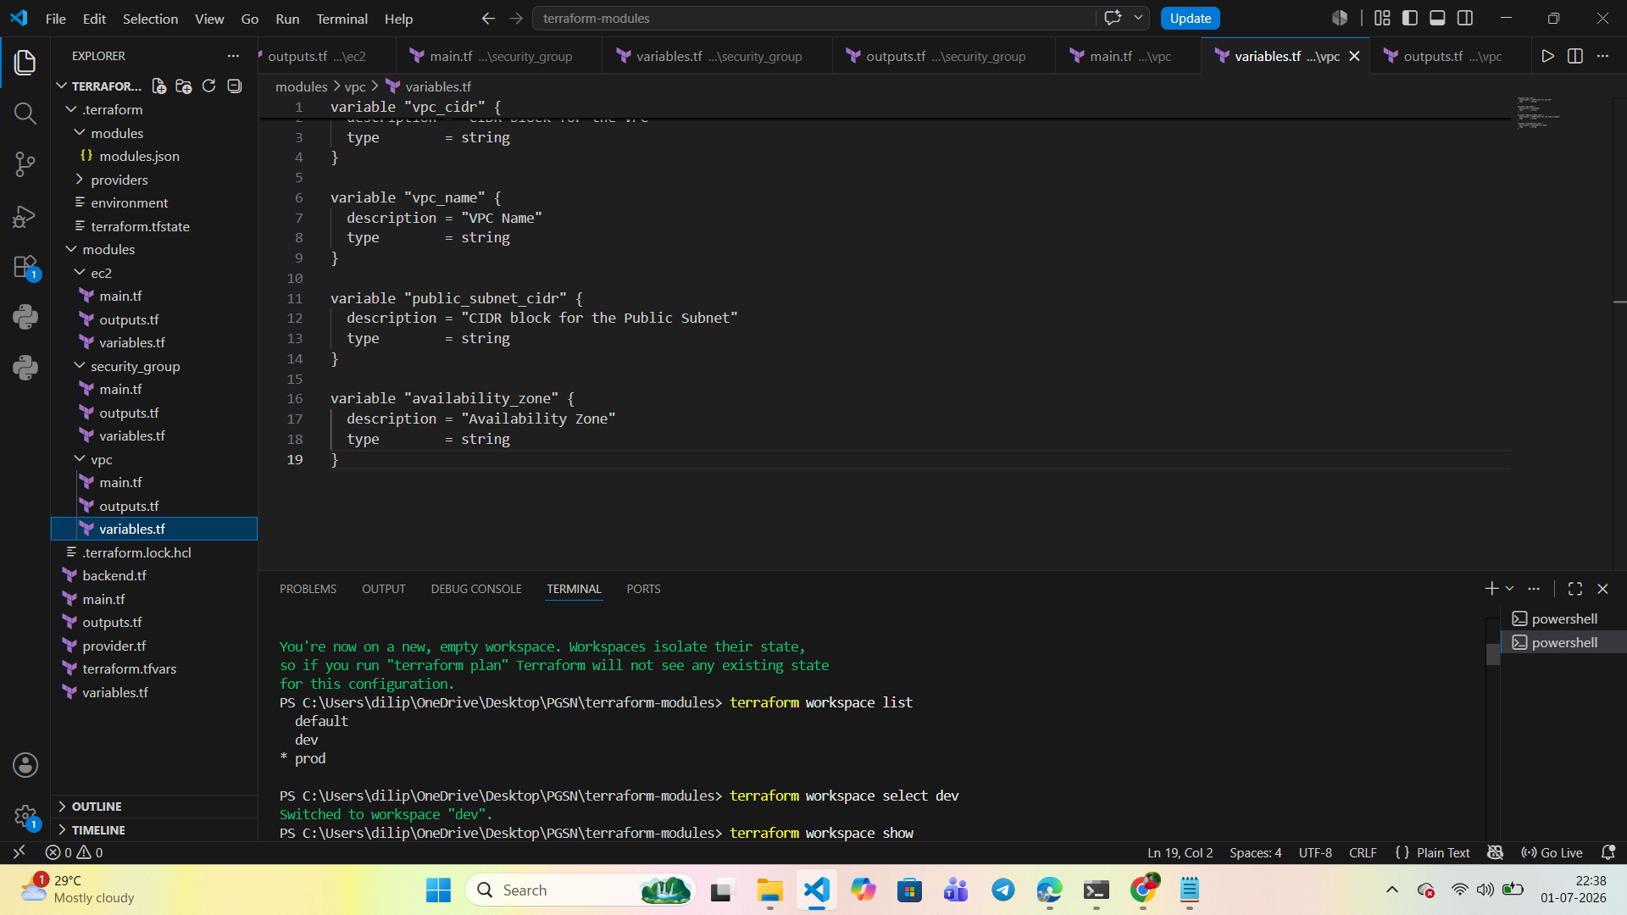
Figure 5: Terraform VPC module variables.tf configuration and workspace selection (dev) in Visual Studio Code.
Once the modules were applied, the EC2 instance (Web-Server) was provisioned successfully inside the custom VPC, confirming that the modular Terraform configuration created the compute resource as expected.
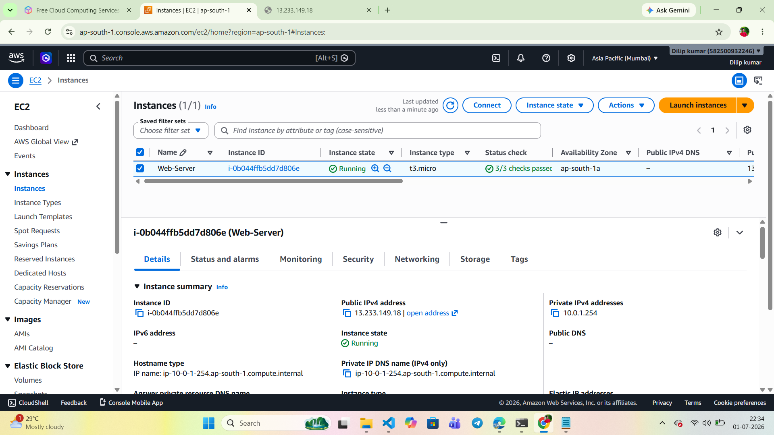
Figure 6: EC2 instance (Web-Server) launched via the modular Terraform configuration, shown running with a t3.micro instance type.
The AWS VPC Console confirms that a dedicated Dev-VPC was created by the reusable VPC module, separate from the default VPC, supporting isolated multi-environment deployments.
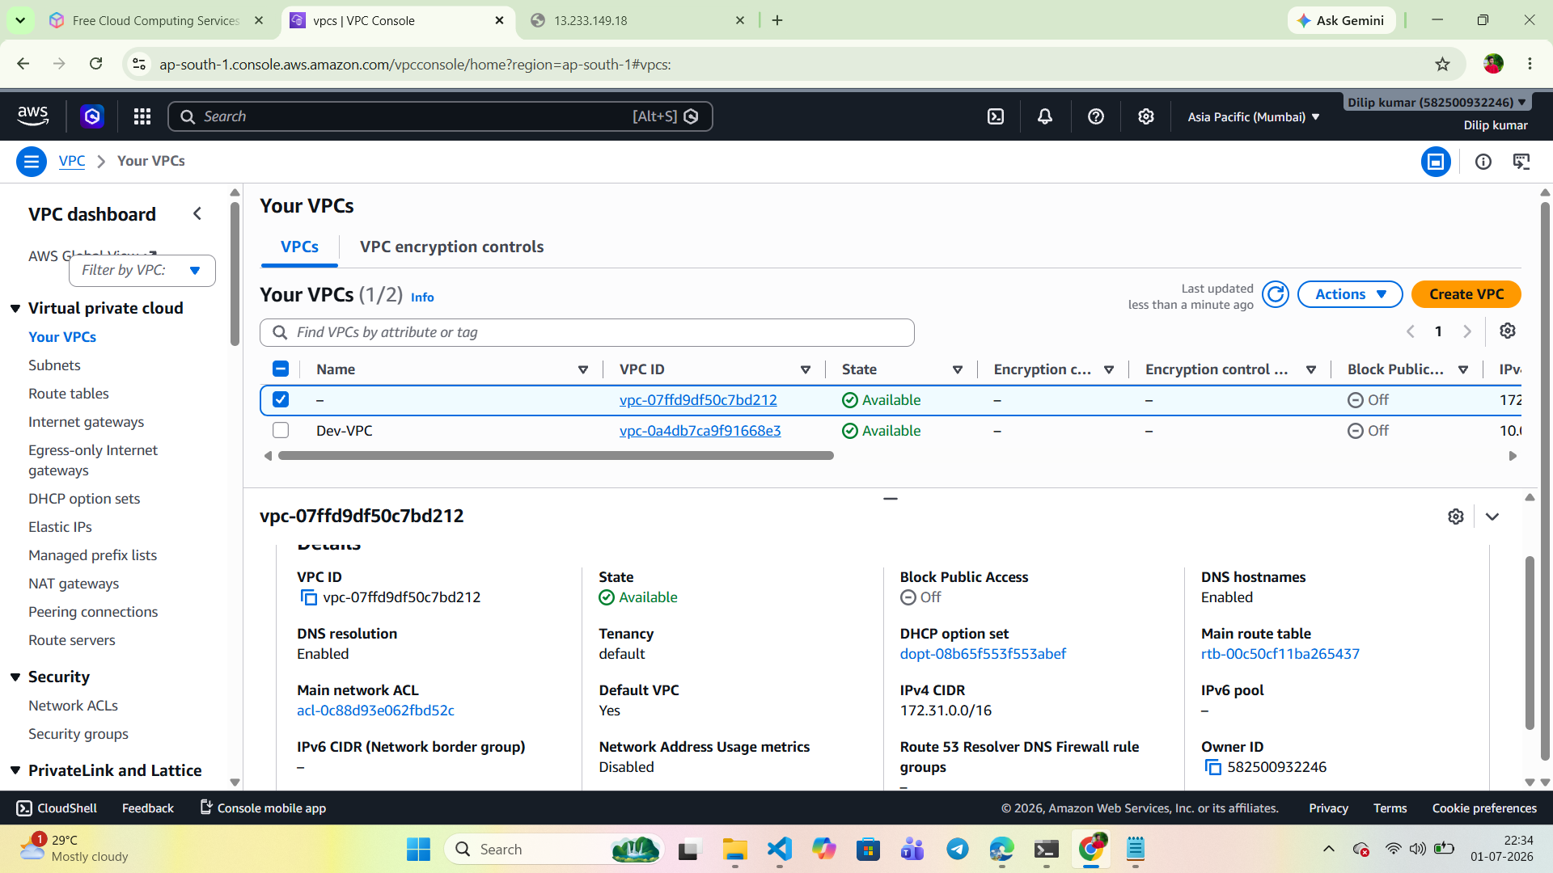
Figure 7: AWS VPC Console showing the Dev-VPC provisioned by the reusable Terraform VPC module.
The Security Group module created a Web-SG security group with inbound rules for HTTPS, HTTP, and SSH traffic, demonstrating that security configuration was successfully modularized alongside networking and compute.
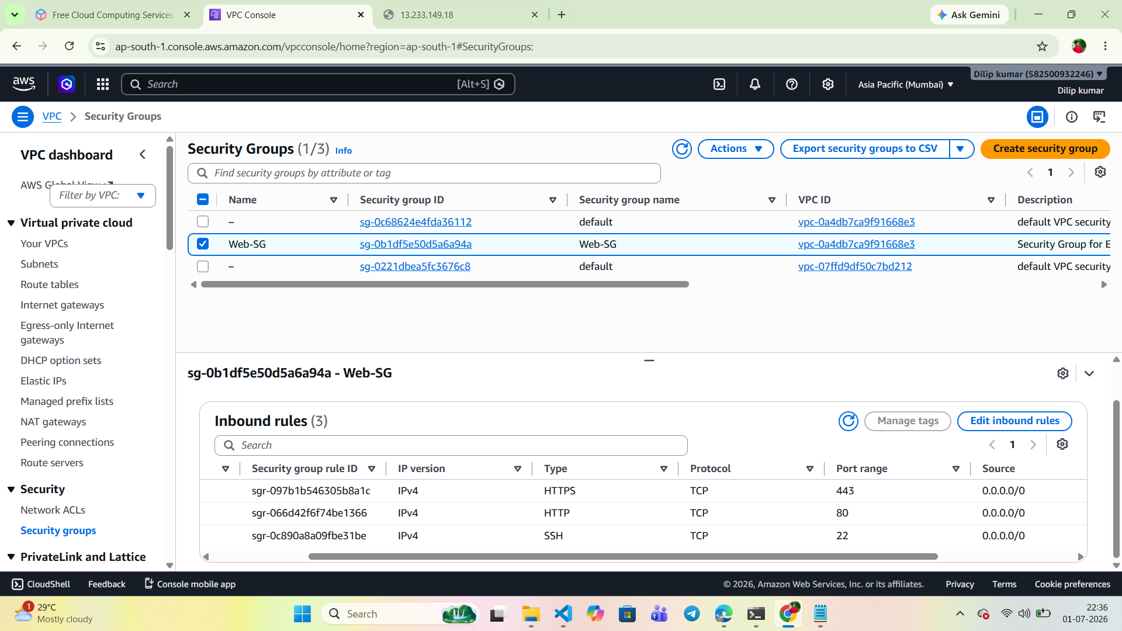
Figure 8: Security Group (Web-SG) created by the Security Group module, showing inbound rules for HTTPS, HTTP, and SSH.
The Terraform apply output confirms that all module resources, including the VPC, route table association, and EC2 instance, were created successfully, with the resulting instance ID and public IP returned as outputs.
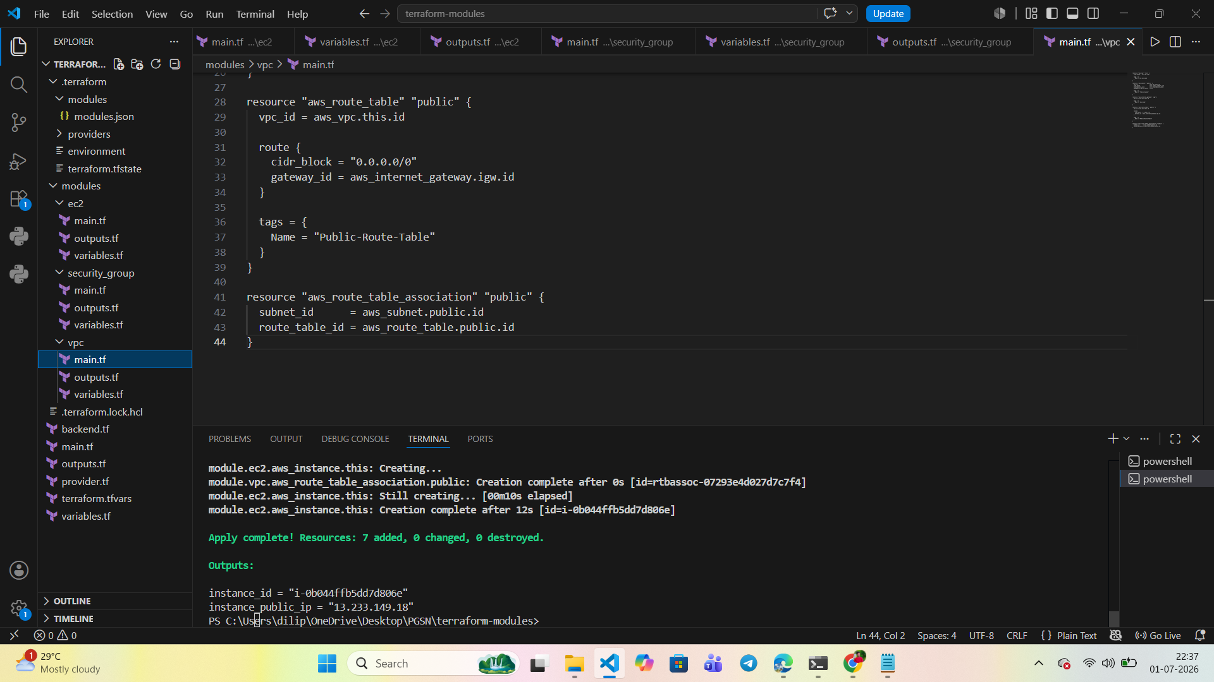
Figure 9: Terraform apply output confirming successful deployment of the VPC, EC2, and Security Group modules, with instance ID and public IP outputs.
The architecture diagram below illustrates the complete modular infrastructure and CI/CD pipeline, showing how source control, Terraform provisioning, the VPC with public and private subnets, containerized compute, and CloudWatch monitoring integrate end to end.
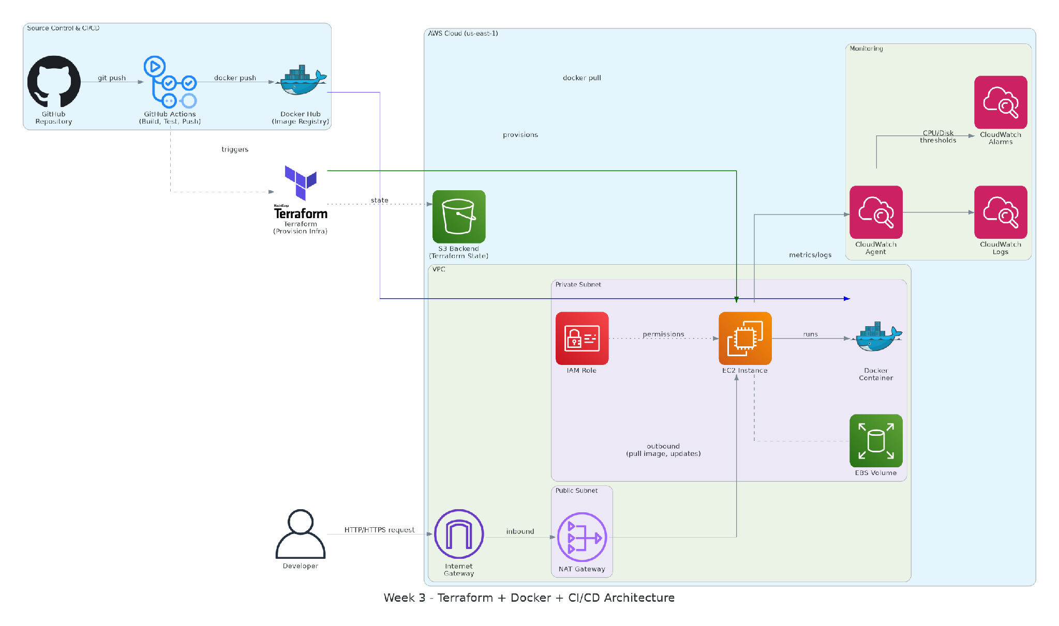
Figure 10: Architecture diagram of the Terraform-provisioned VPC, EC2, and CI/CD monitoring pipeline used across the Week 3 modular infrastructure.

Day 3 – Docker Fundamentals

Topics Covered
- Docker Architecture
- Docker Images
- Containers
- Dockerfile
- Docker Volumes
- Docker Networking

Implementation
Docker was installed and used to containerize a sample Flask web application. A Dockerfile was authored to define the image build process, after which the image was built and run locally to validate functionality before pushing it to a remote registry.
- Installed Docker.
- Created a Dockerfile for a sample web application.
- Built a Docker image from the Dockerfile.
- Ran the container locally and verified accessibility.
- Mounted persistent volumes for data durability.
- Pushed the Docker image to Docker Hub.
The screenshot below confirms that the containerized Flask application was successfully running locally and reachable through the mapped port.
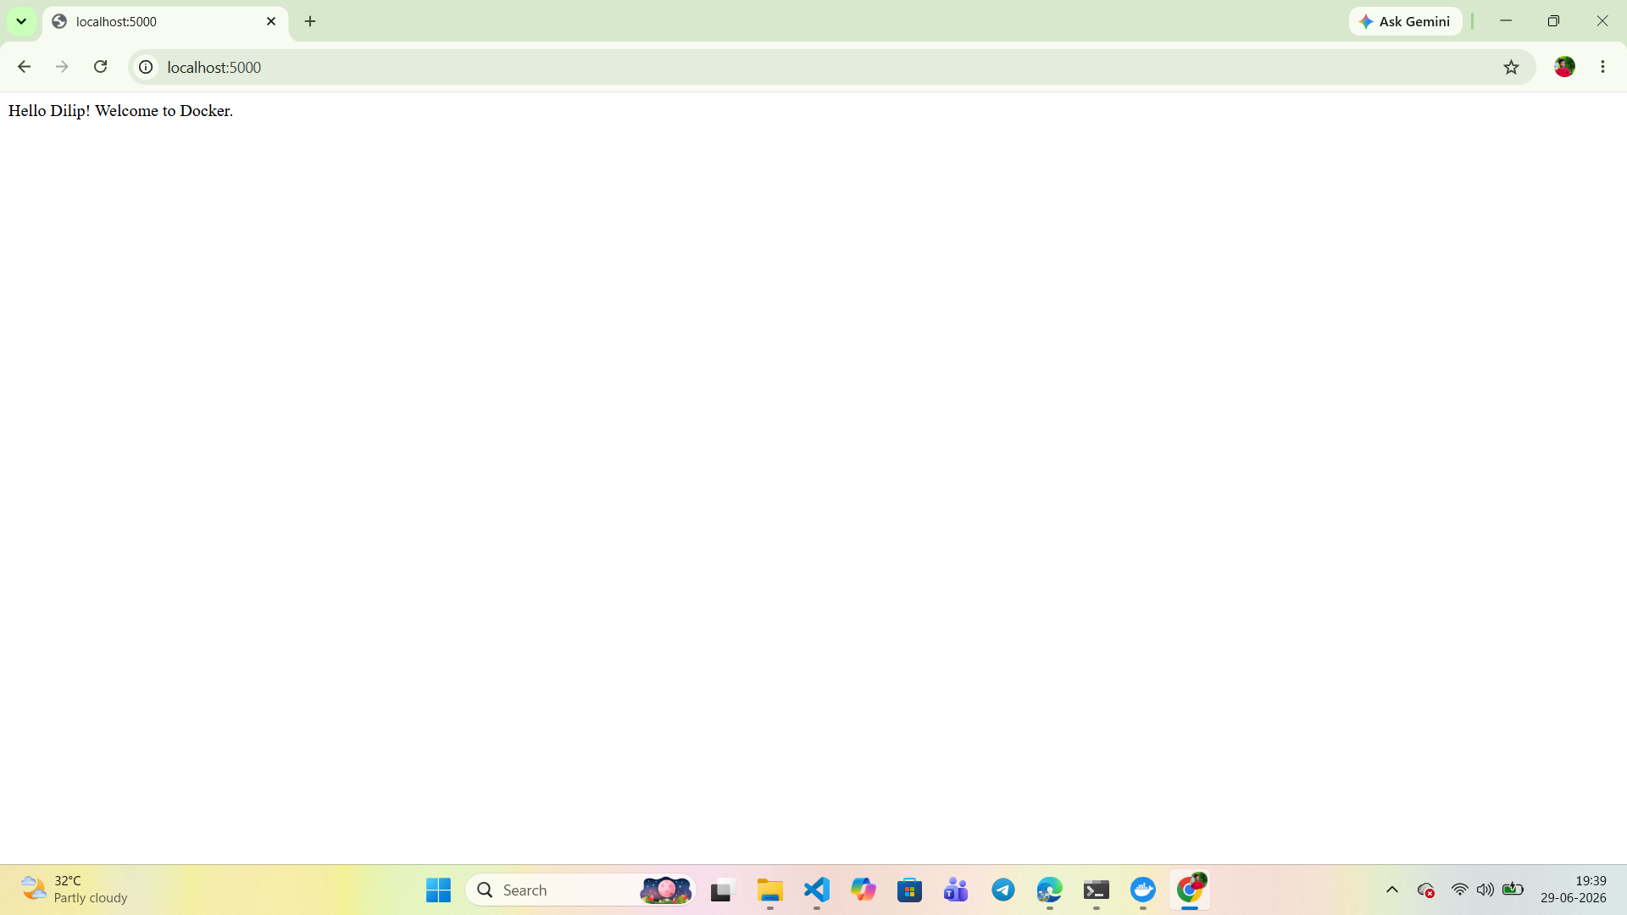Figure 11: Flask application running inside a Docker container, accessed locally at localhost:5000.
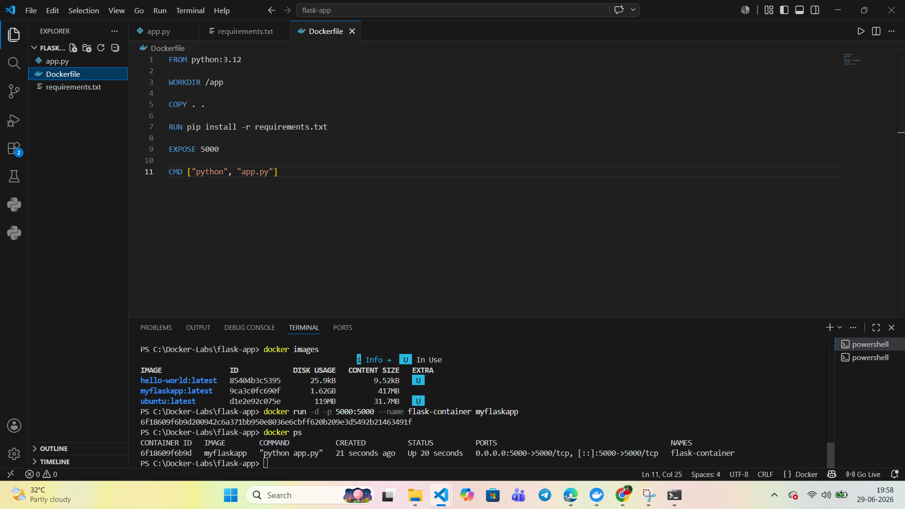

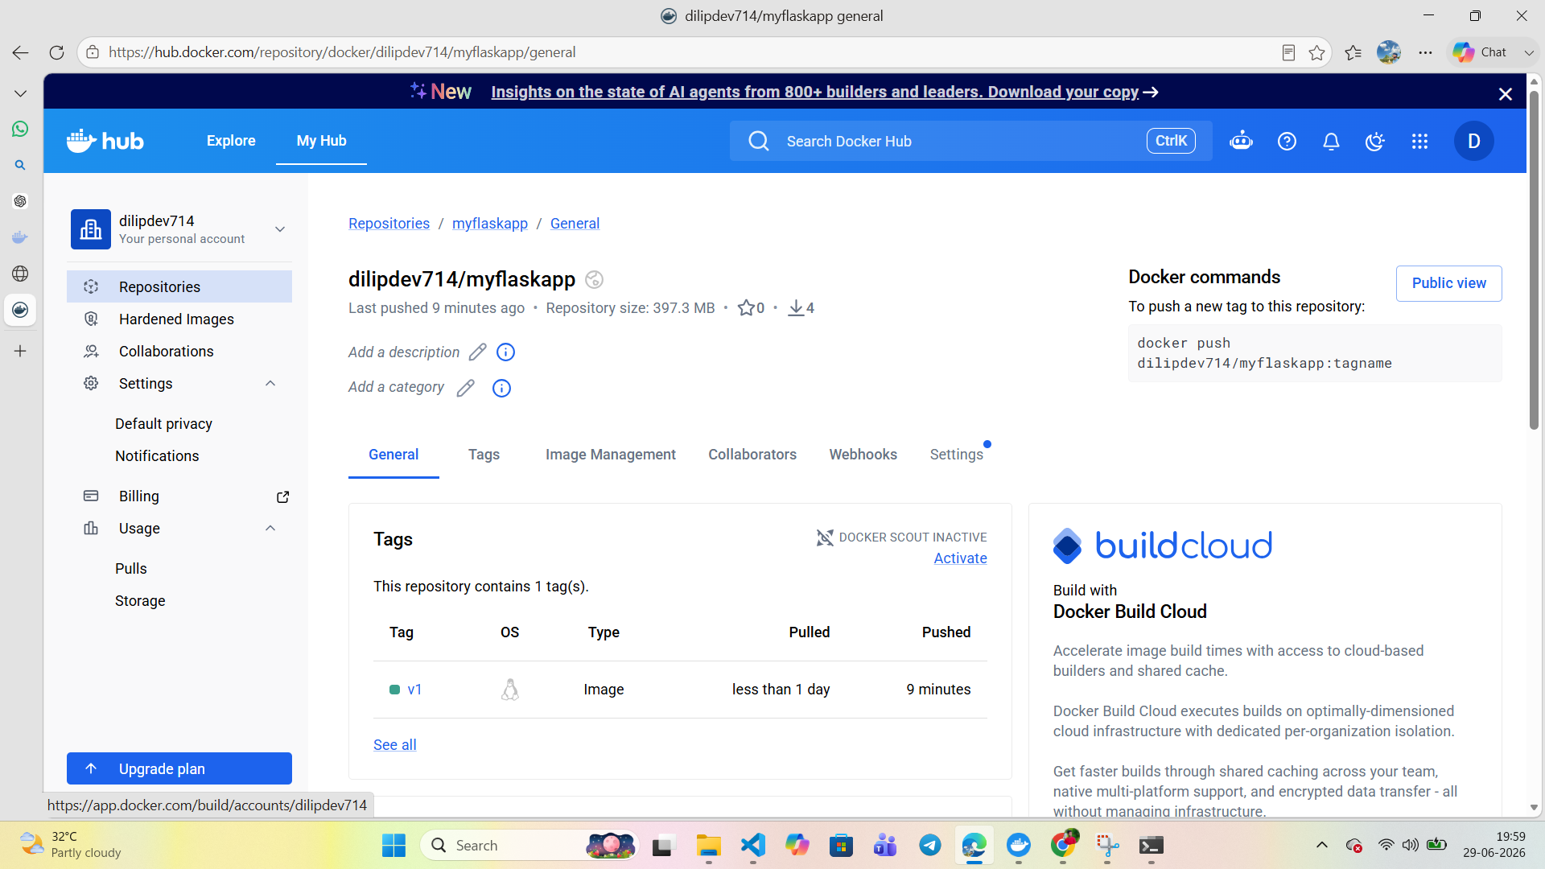

Day 4 – CI/CD with GitHub Actions

Topics Covered
- Continuous Integration
- Continuous Deployment
- GitHub Actions
- Workflow Files
- Secrets Management

Implementation
A GitHub repository was created to host the application source code, and a GitHub Actions workflow was configured to automate building, testing, and image publishing on every push, removing the need for manual intervention.
- Created a GitHub repository.
- Configured GitHub Actions workflow files.
- Automatically built the application on every push.
- Ran unit tests as part of the pipeline.
- Built the Docker image within the pipeline.
- Pushed the Docker image to Docker Hub automatically.
The Docker Hub repository confirms that the image was published successfully and is available for deployment.
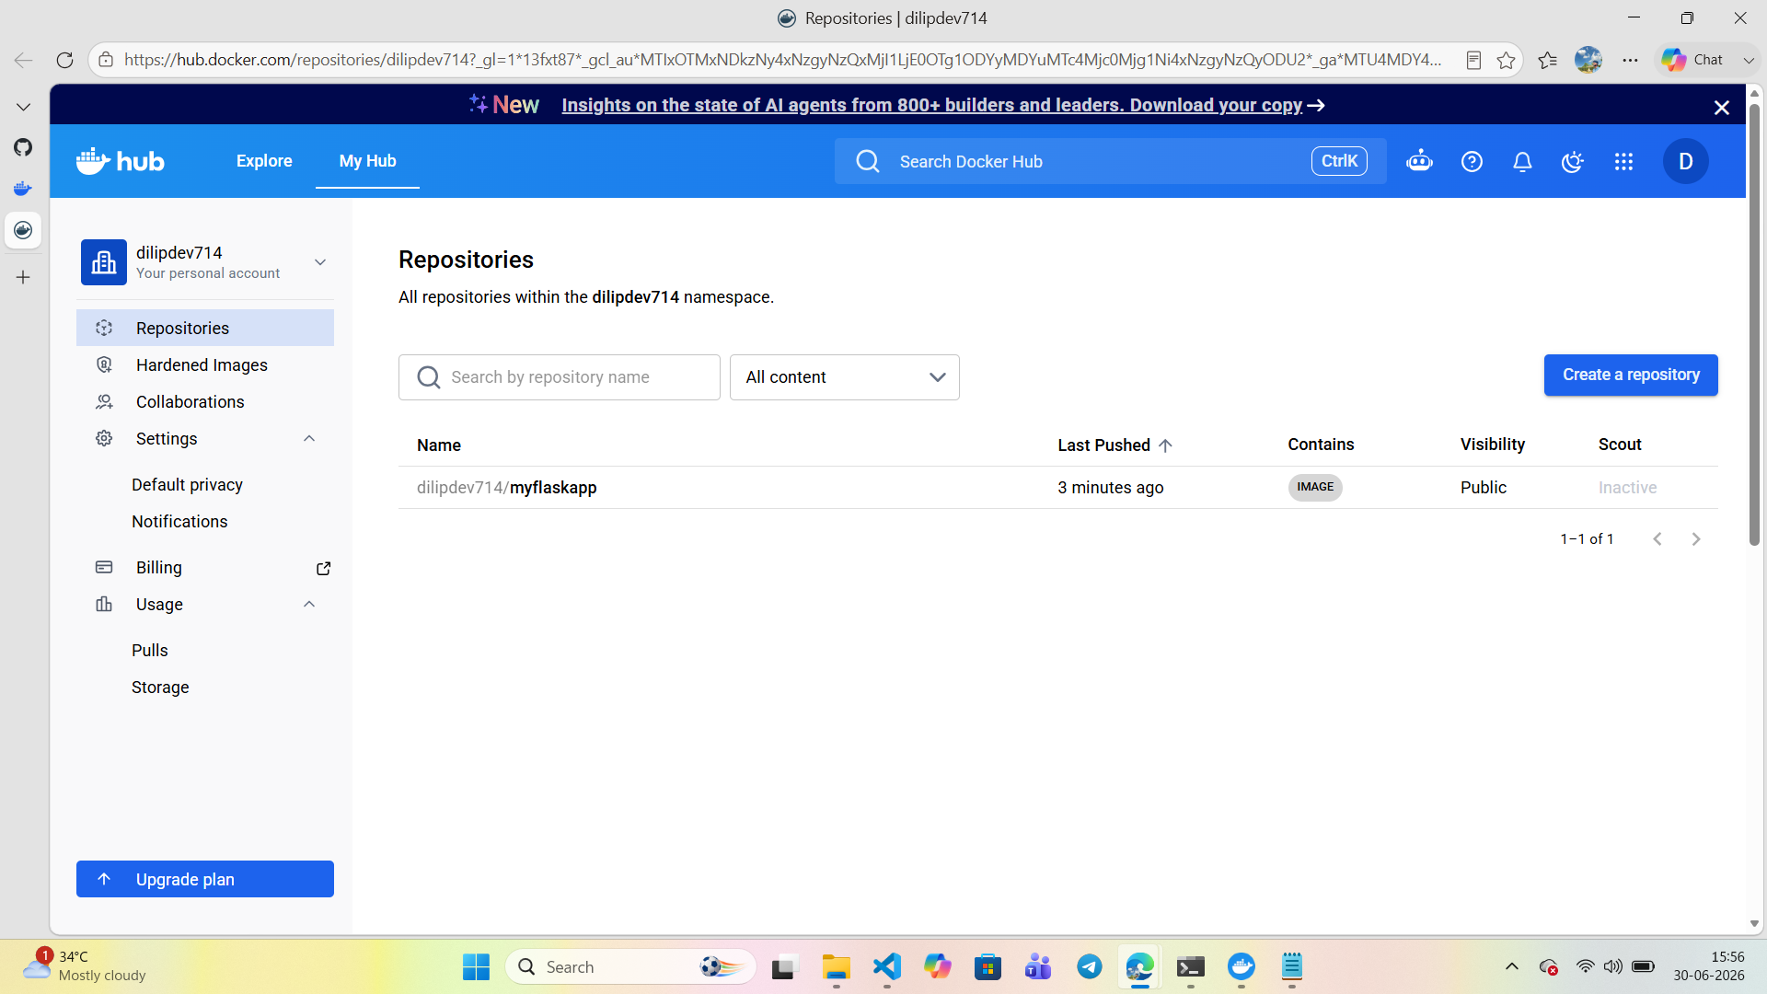
Figure 12: Docker image (myflaskapp) published to Docker Hub, confirming a successful automated image push.
The GitHub repository confirms the presence of the workflow files, Dockerfile, application code, and test suite that together form the CI/CD pipeline.
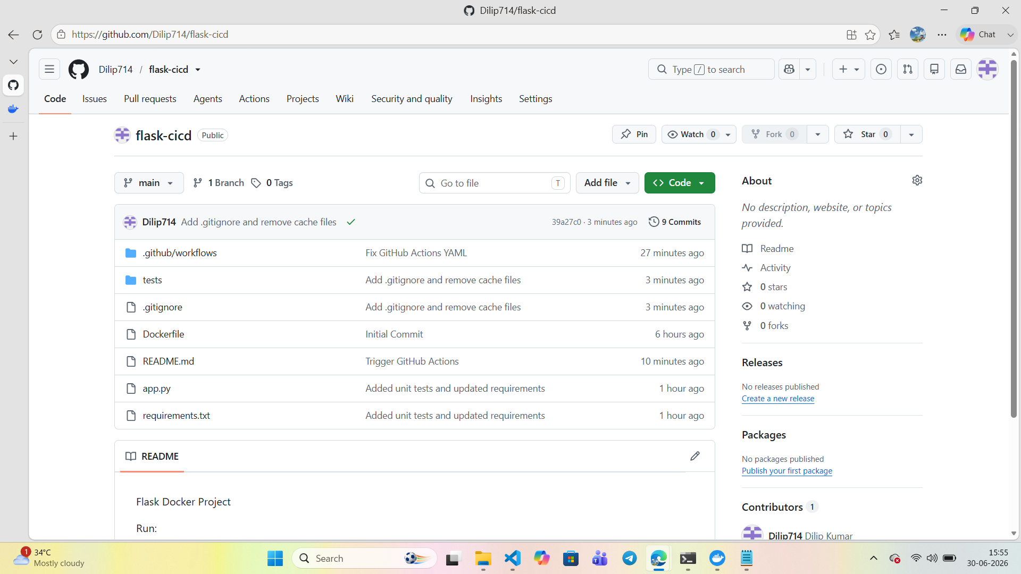
Figure 13: GitHub repository (flask-cicd) containing the GitHub Actions workflow, Dockerfile, application code, and unit tests.

Day 5 – AWS Deployment Automation

Topics Covered
- Code Deployment Strategies
- Environment Variables
- Deployment Automation

Implementation
Deployment automation was implemented end-to-end using Terraform to launch the EC2 instance and a User Data script to install Docker, pull the published image, and run the application automatically at boot time, eliminating manual server configuration.
- Launched an EC2 instance using Terraform.
- Installed Docker automatically using EC2 User Data.
- Pulled the Docker image from Docker Hub.
- Ran the application container automatically.
- Verified application accessibility over the public IP.
Accessing the EC2 instance's public IP address in a browser confirmed that the Flask application was deployed and served automatically without manual server setup.
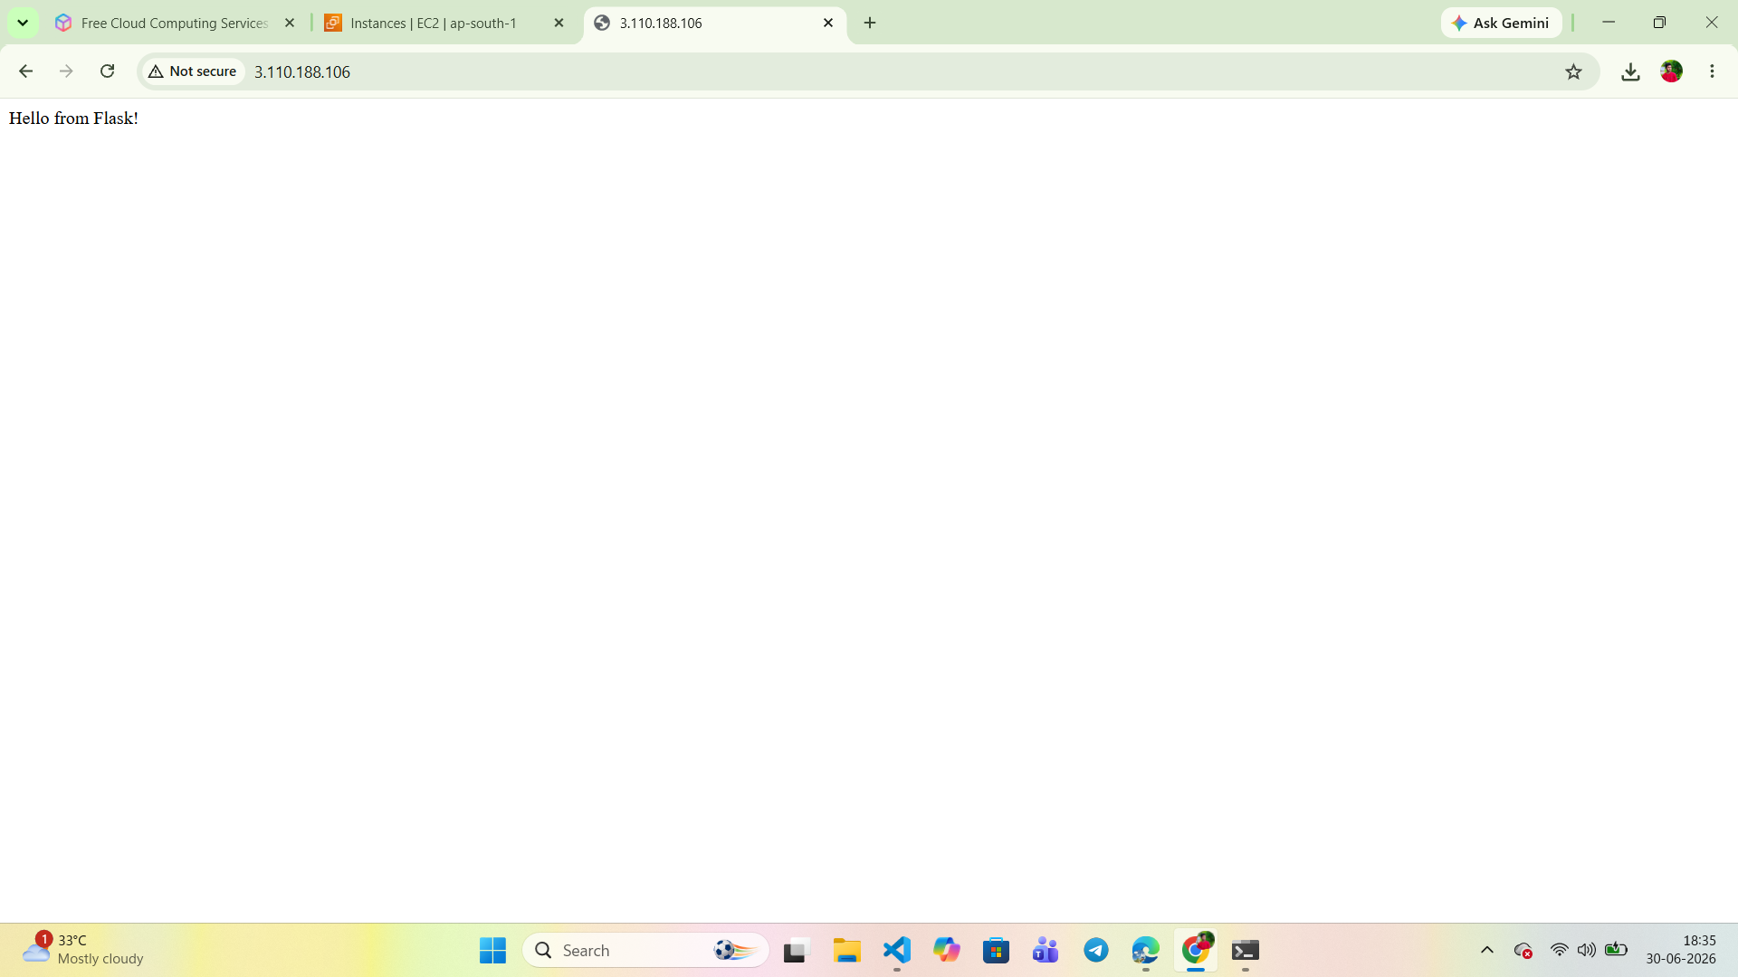
Figure 14: Flask application deployed and accessible via the EC2 instance’s public IP address (3.110.188.106).
The Terraform apply output below verifies that the EC2 instance was created successfully and that the public IP output value matches the deployed application.
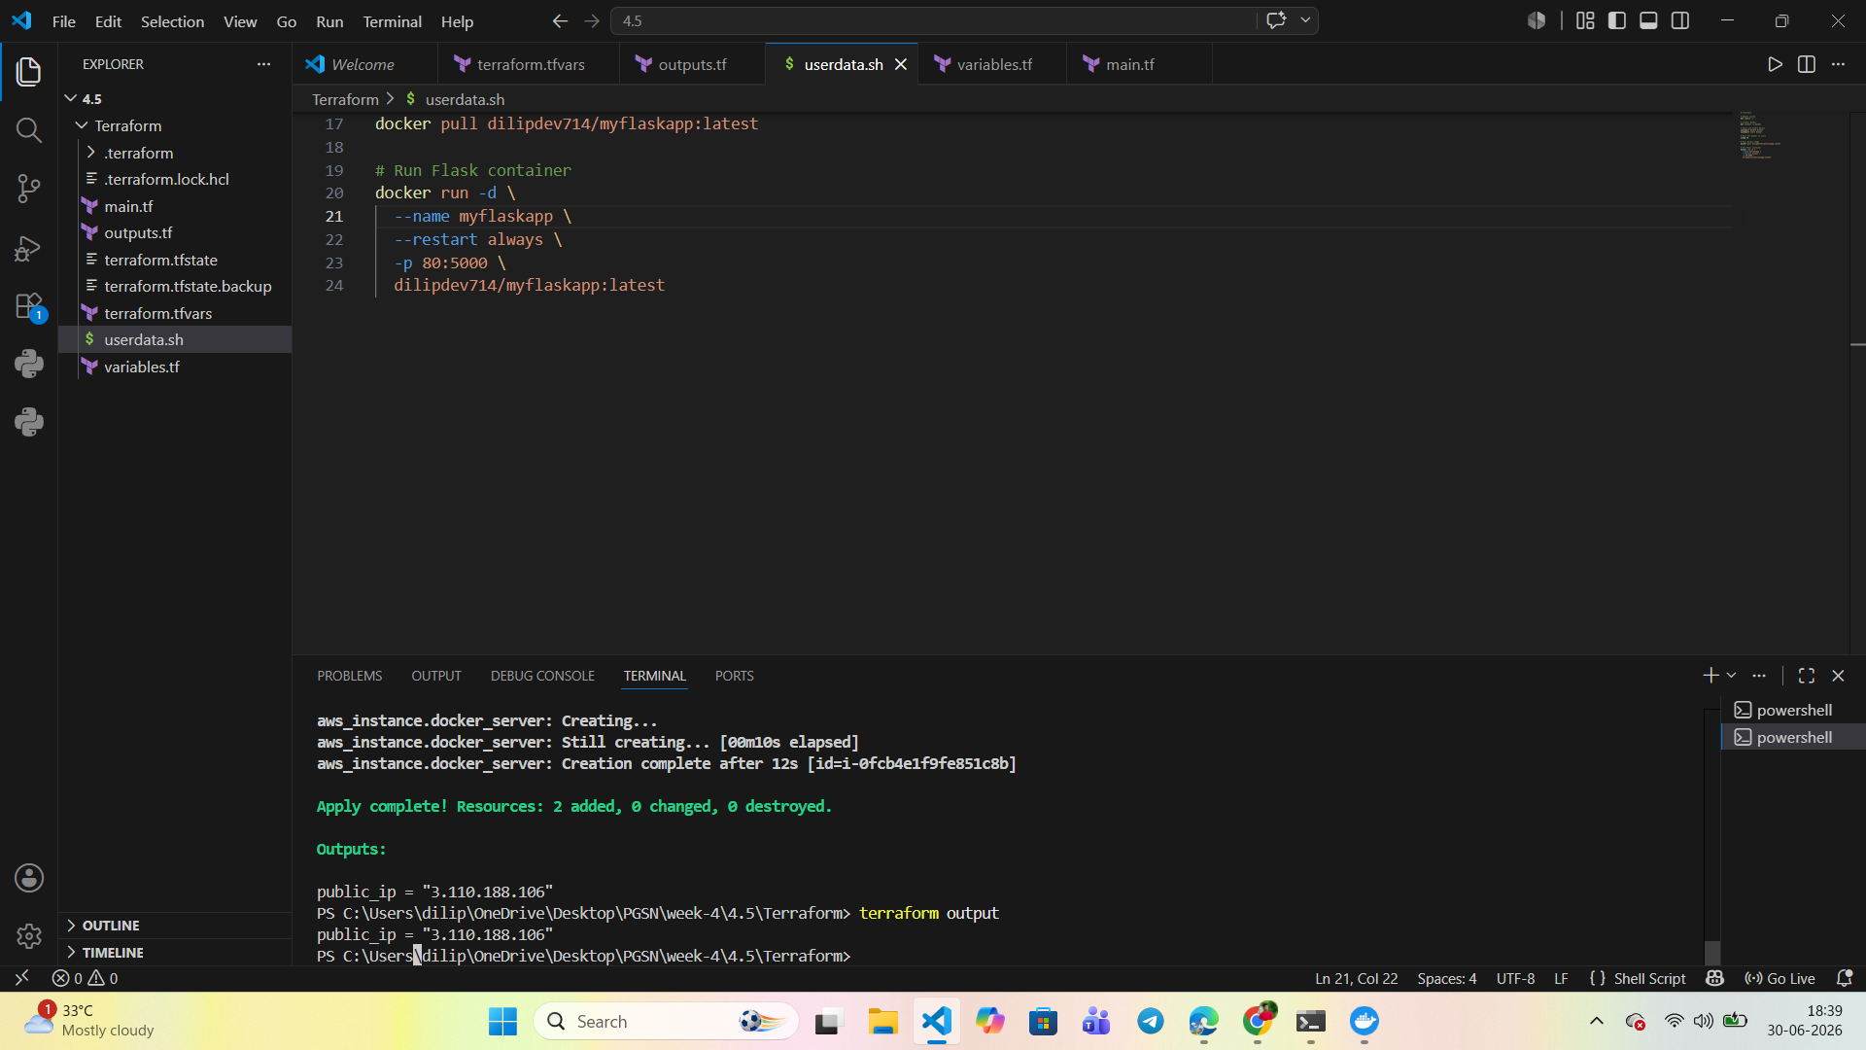
Figure 15: Terraform apply output showing successful EC2 provisioning and the resulting public IP address.

Day 6 – Monitoring & Logging

Topics Covered
- Docker Logs
- CloudWatch Logs
- CloudWatch Alarms
- Application Monitoring

Implementation
Monitoring was configured using Amazon CloudWatch to track application health and infrastructure performance. The CloudWatch Agent was installed on the EC2 instance to forward Docker container logs, and CloudWatch Alarms were created with SNS notifications for CPU and disk utilization thresholds.
- Configured the CloudWatch Agent on the EC2 instance.
- Sent application and container logs to CloudWatch Logs.
- Created a CPU utilization alarm.
- Created a disk usage alarm.
- Verified alarm notifications through SNS subscriptions.
An Amazon SNS subscription confirmation email was received to enable alarm notifications for the monitoring topic.
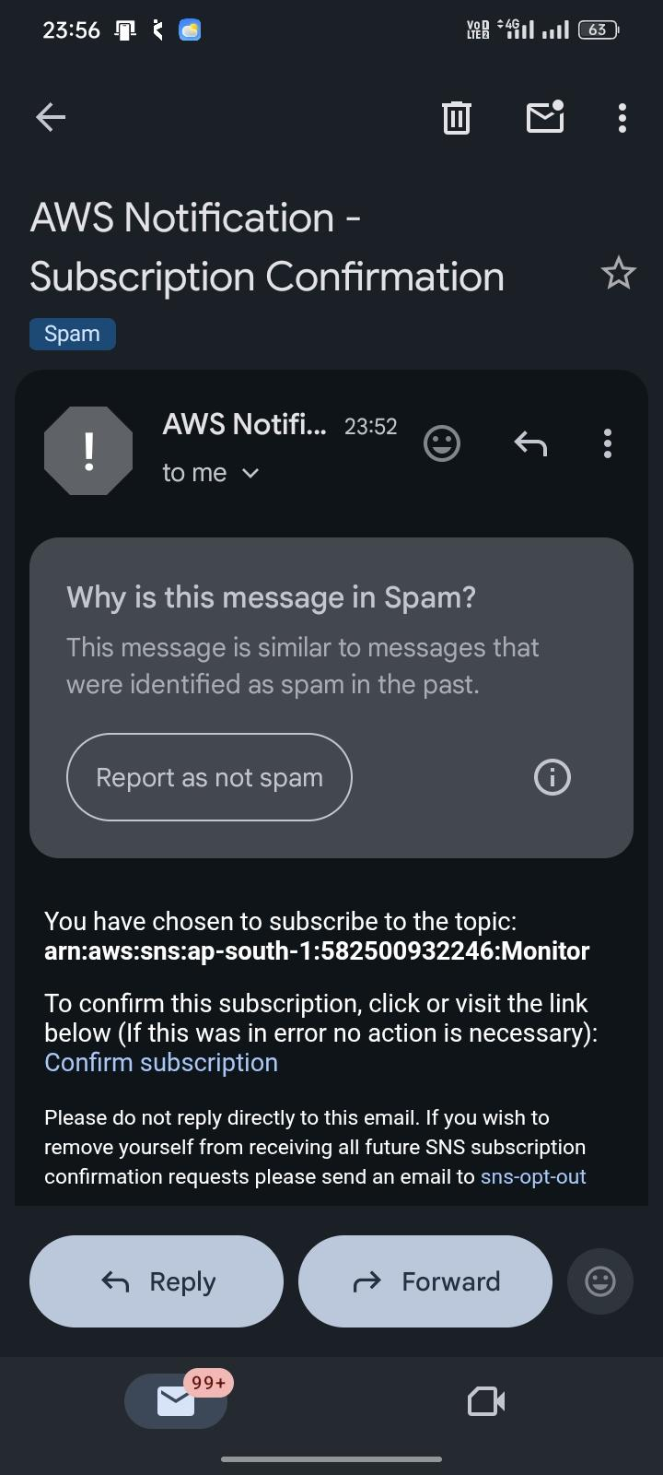
Figure 16: Amazon SNS subscription confirmation email for the CloudWatch alarm notification topic.
The CloudWatch Agent installation was performed on the EC2 instance to enable custom metric collection, such as disk utilization, which is not available by default.
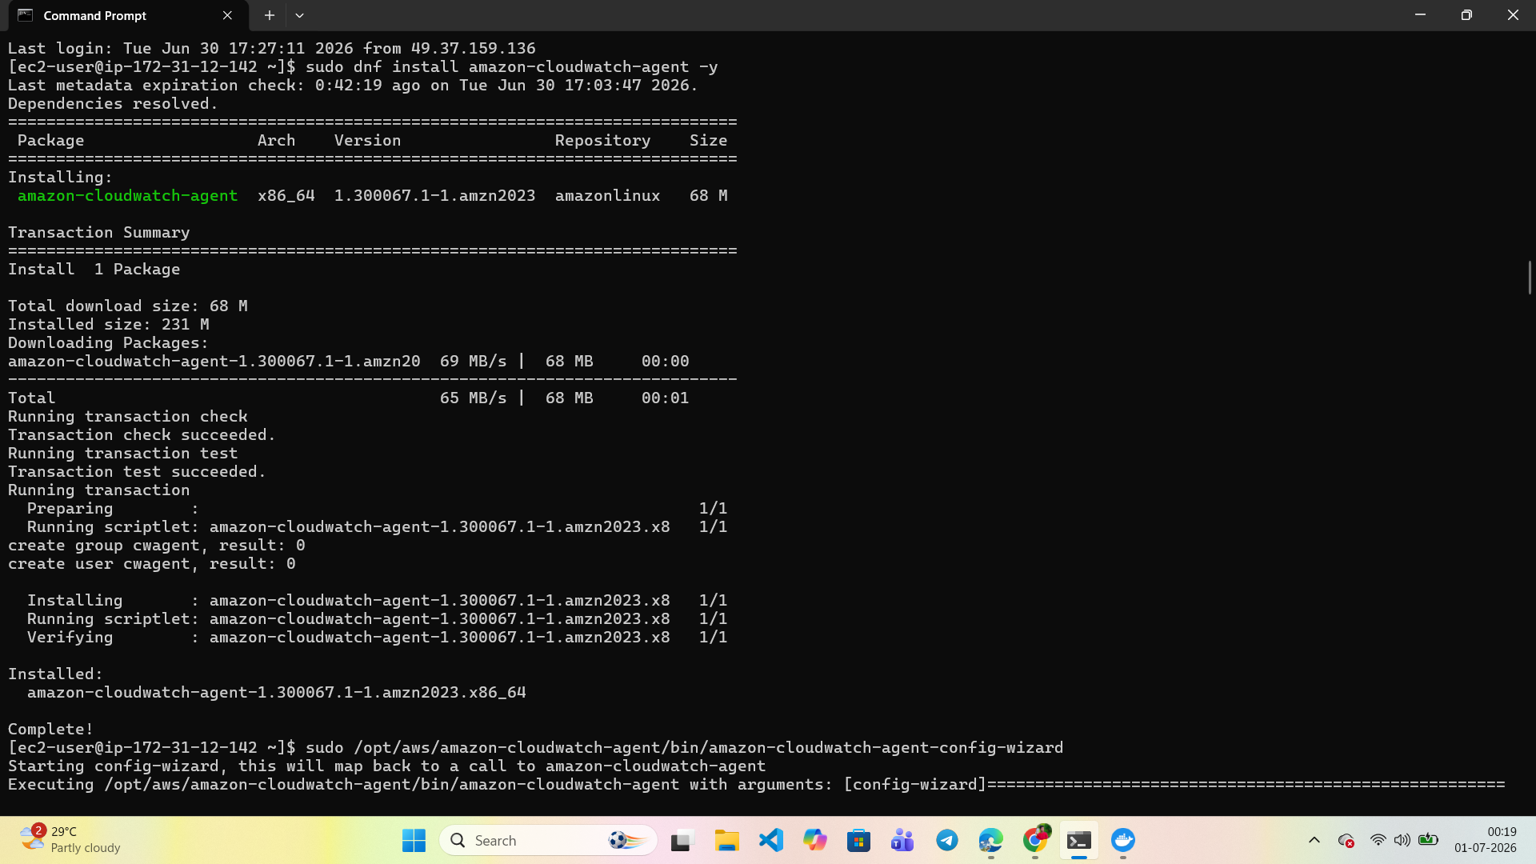
Figure 17: Installation of the Amazon CloudWatch Agent on the EC2 instance via the AWS CLI.
Two CloudWatch Alarms were created to monitor CPU and disk utilization, each configured to trigger notifications when thresholds are breached.
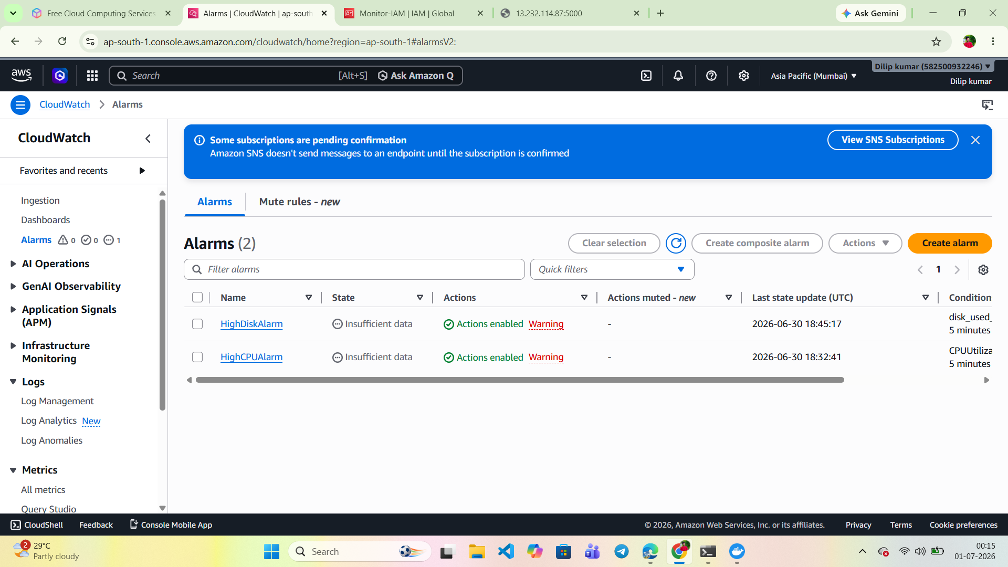
Figure 18: CloudWatch Alarms (HighCPUAlarm and HighDiskAlarm) configured with SNS notification actions enabled.
Docker container logs were verified directly on the EC2 instance via SSH to confirm the application was serving requests correctly before forwarding logs to CloudWatch.
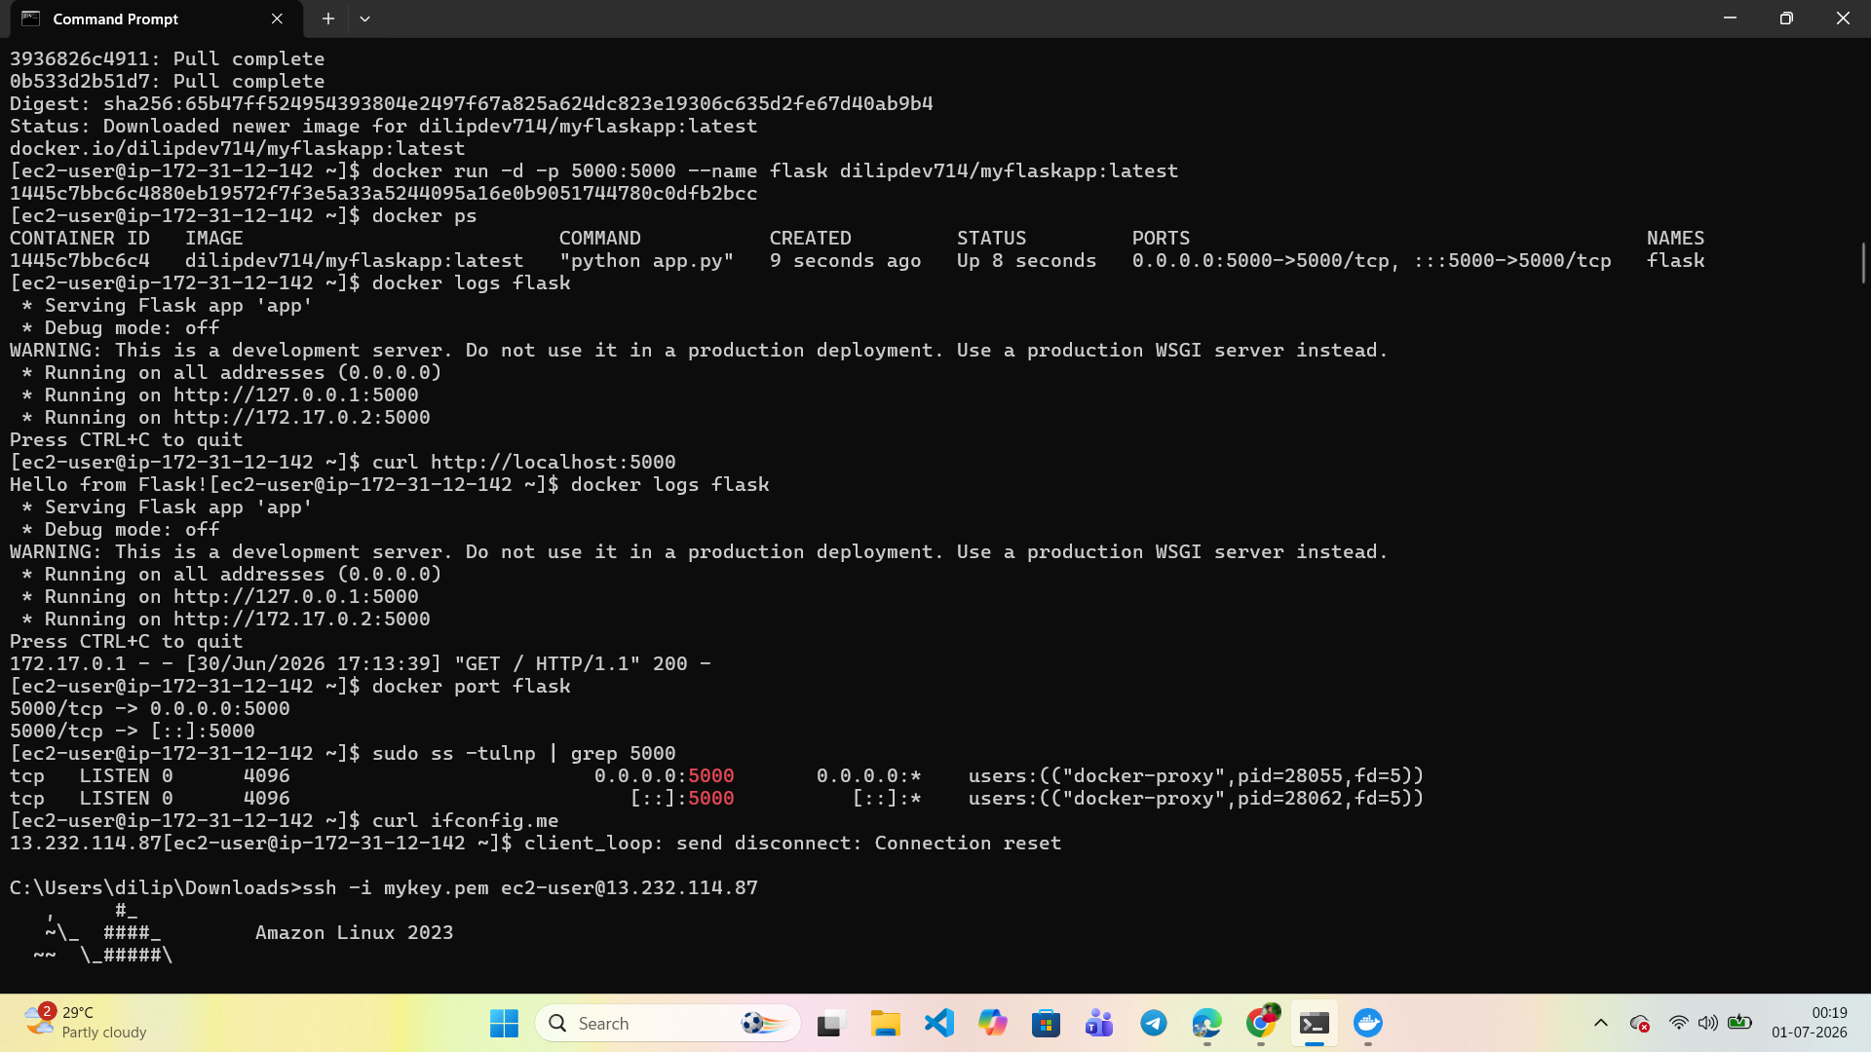
Figure 19: SSH session into the EC2 instance showing Docker container status and Flask application logs.
A dedicated CloudWatch Log Group was created to collect and centralize Docker container logs from the EC2 instance.
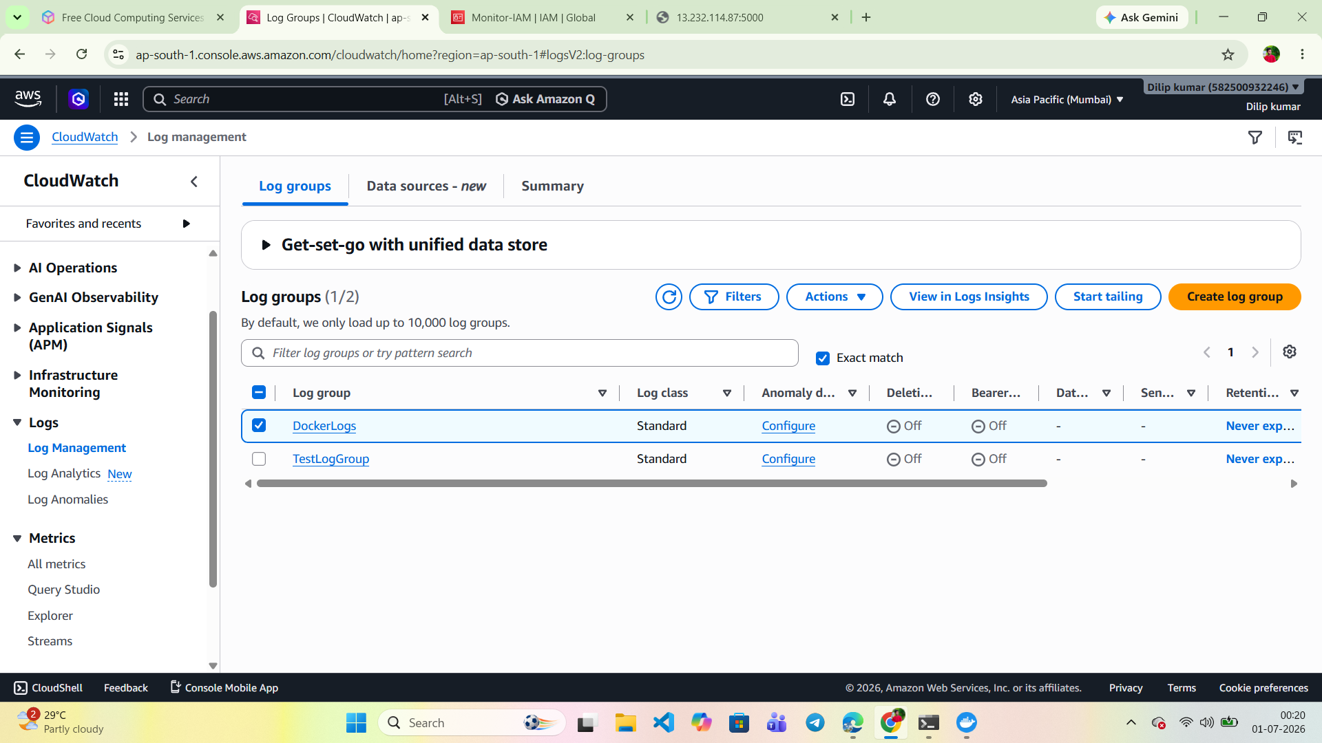
Figure 20: CloudWatch Log Groups showing the DockerLogs group used for centralized log collection.
Amazon SNS Topics were configured to route alarm notifications to the appropriate subscribers.
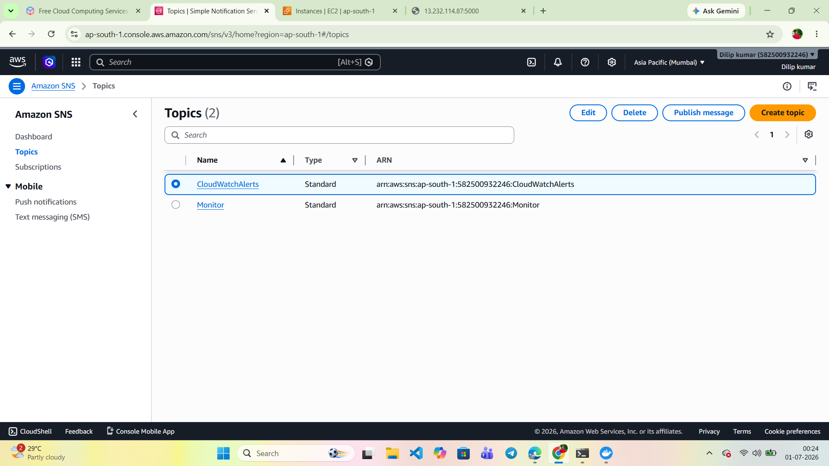
Figure 21: Amazon SNS Topics (CloudWatchAlerts and Monitor) configured for alarm notification delivery.

Day 7 – Final Project

Project Overview
The final project consolidated all concepts covered during the week into a single, production-ready deployment. The complete infrastructure was provisioned using modular Terraform configurations, and the application was containerized, deployed, and monitored using the CI/CD and observability pipeline built throughout the week.

Technology Stack Used
- Terraform
- AWS VPC
- EC2
- Security Groups
- IAM Roles
- S3 Backend
- Docker
- GitHub Actions
- CloudWatch

Deliverables
- GitHub Repository
- Terraform Code
- Dockerfile
- GitHub Actions Workflow
- Architecture Diagram
- Deployment Guide
- README
- Screenshots of deployment and monitoring

Bonus Objectives
- Use of Terraform Modules.
- Use of a Remote Backend.
- HTTPS configuration with an Nginx reverse proxy.
- Zero Downtime Deployment implementation.
- Auto Deployment configured on every Git push.
The final Terraform apply confirms that the complete infrastructure stack — including the VPC, subnet, security group, and EC2 instance — was provisioned successfully with all output values (public IP, public DNS, subnet ID, security group ID, and VPC ID) returned correctly.
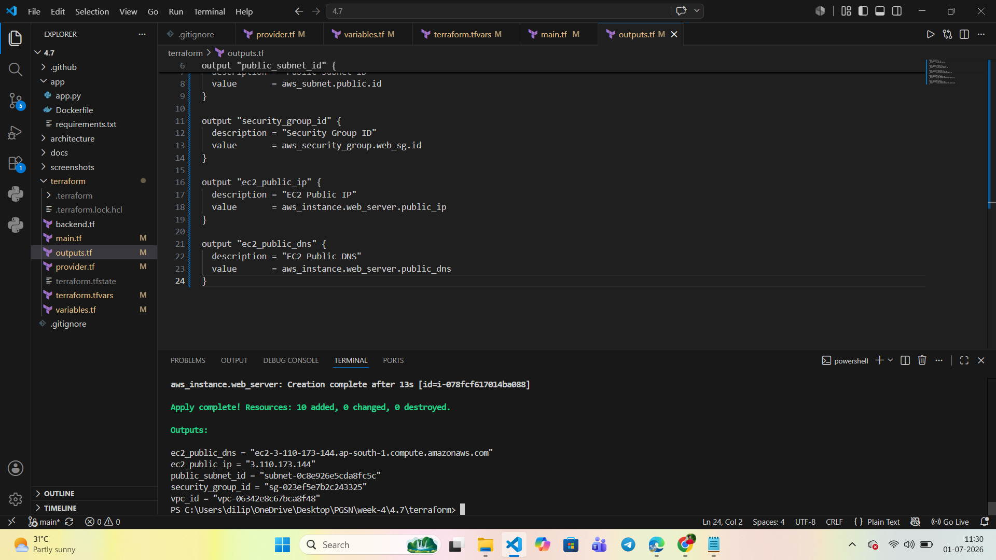
Figure 22: Final Terraform apply output confirming successful provisioning of all ten infrastructure resources.
CloudWatch Metrics confirm that the custom disk utilization metric was successfully published from the EC2 instance, validating that the monitoring pipeline configured in Day 6 functions correctly within the final production deployment.
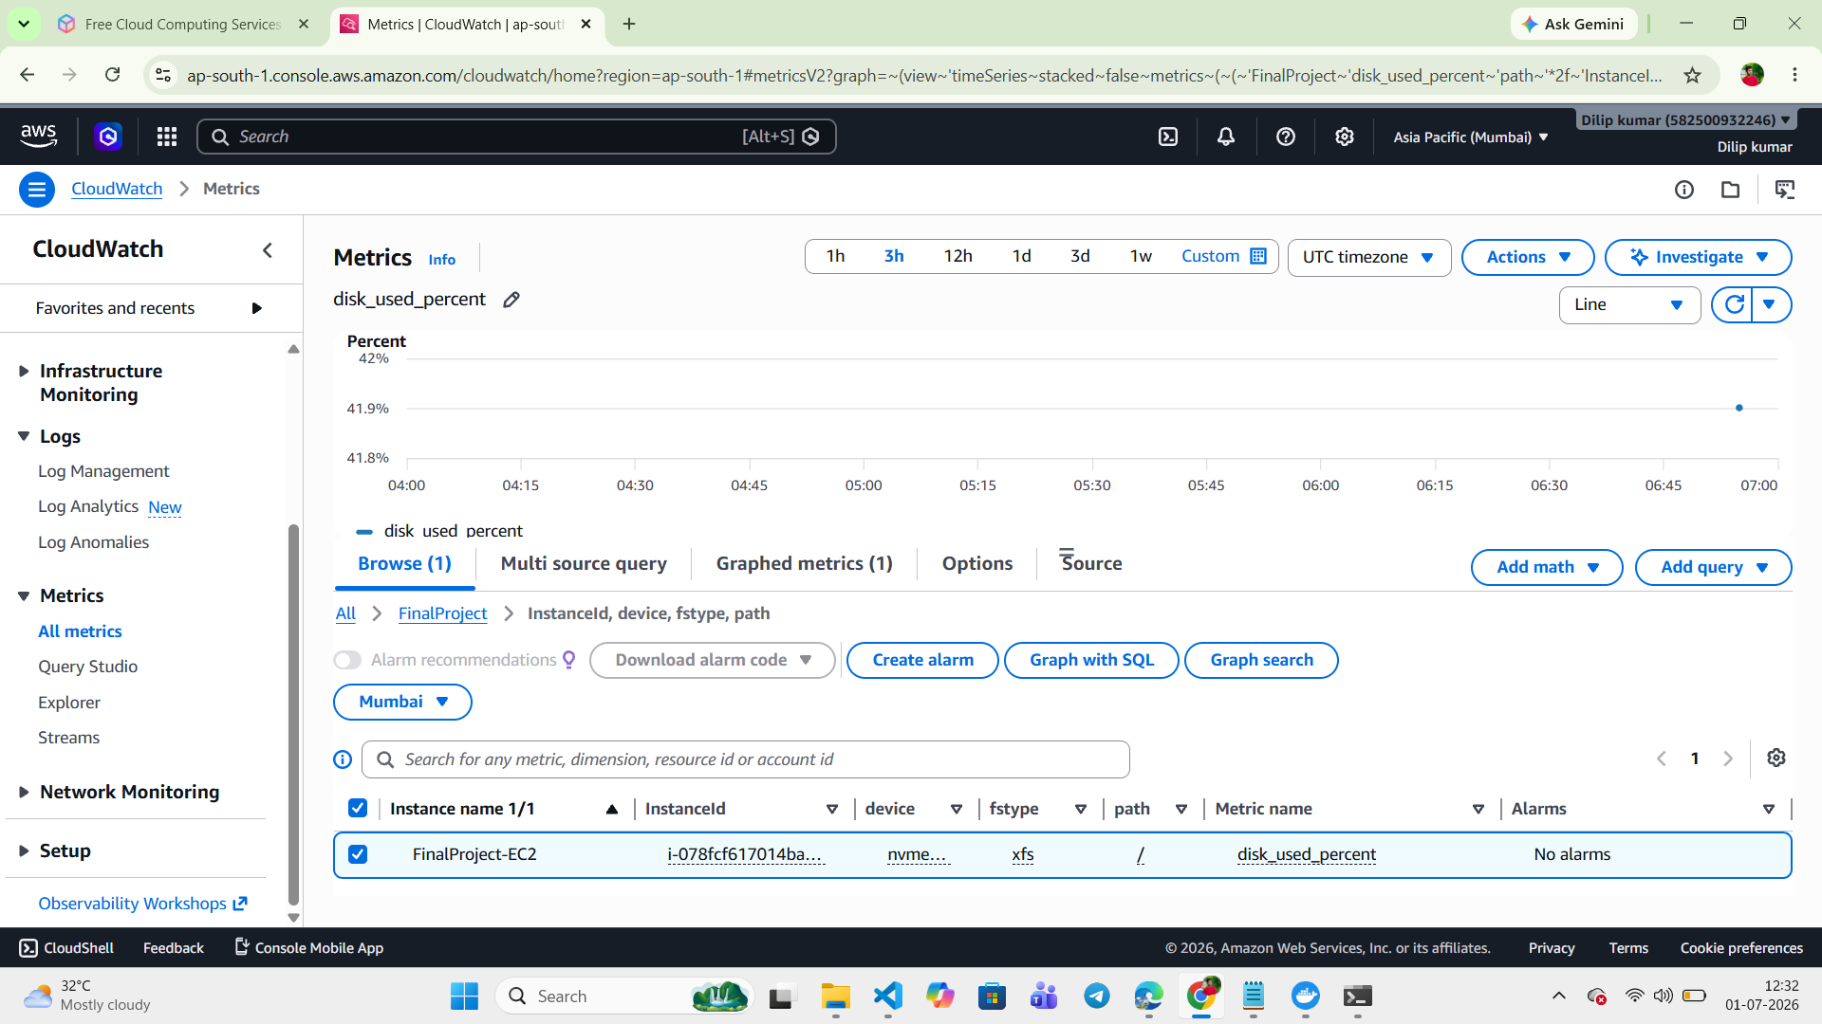
Figure 23: CloudWatch custom metric (disk_used_percent) graph for the final project EC2 instance.

Conclusion
Over the course of the week, infrastructure provisioning, containerization, CI/CD automation, and cloud monitoring were successfully integrated into a single automated deployment pipeline. This exercise demonstrated a practical, end-to-end understanding of modern DevOps practices using Terraform, Docker, GitHub Actions, and Amazon CloudWatch.

